Sri Lanka Institute of Information

Technology



Lab Submission

Lab sheet 06

**IT24200536**

**Karunarathna B.G.C.N.S.**

**IT2120- Probability and Statistics**

B.Sc. (Hons) in Information Technology

**Question 1**

Part 1

Part 2

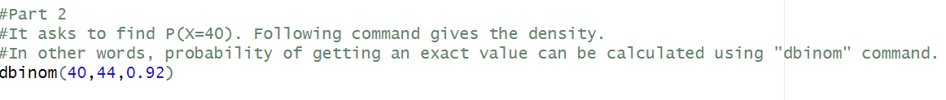

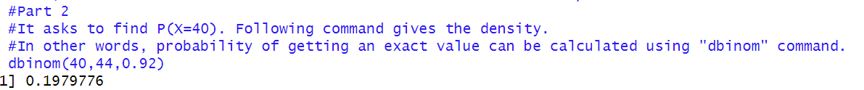

Part 3

Part 4

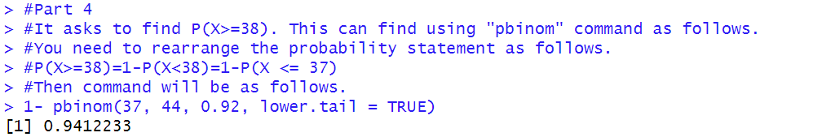

Part 5

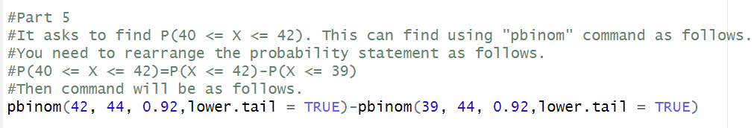

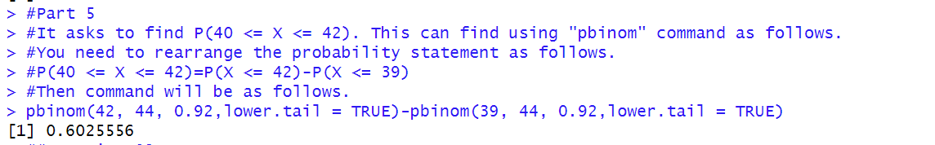

Question 2

Part 1

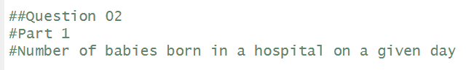



Part 2  
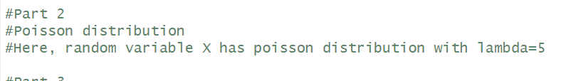

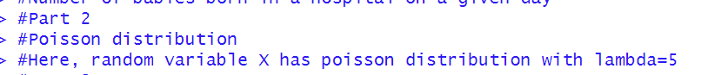

Part 3

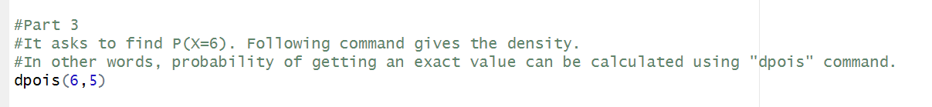



Part 4

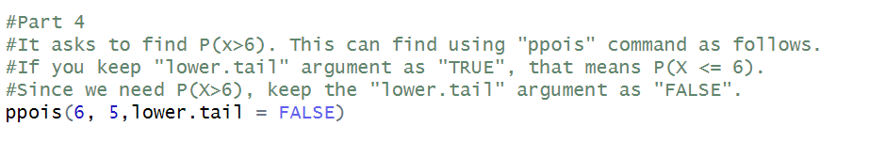

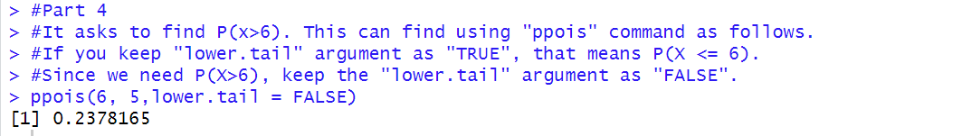

Exercise 2

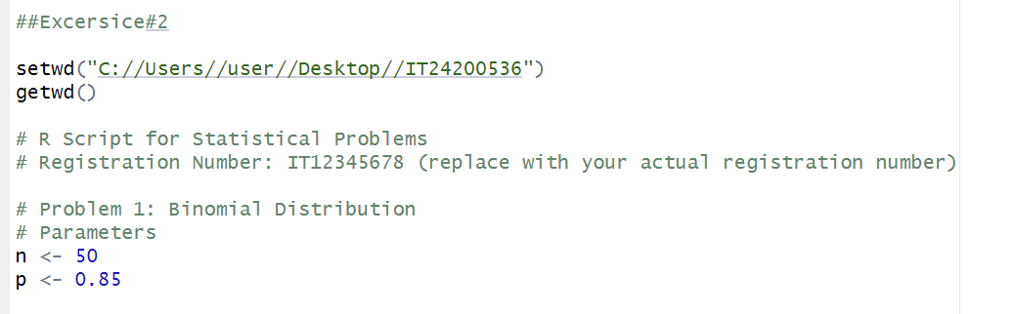

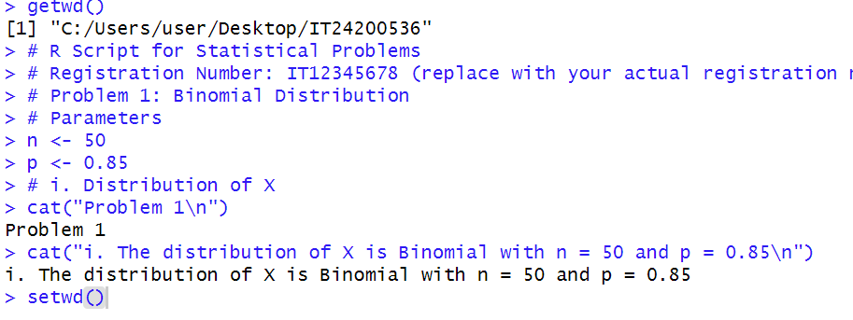

01)

1. 

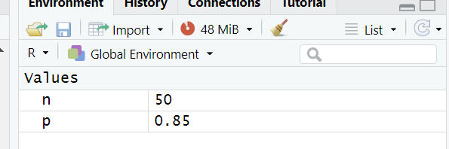



2.



